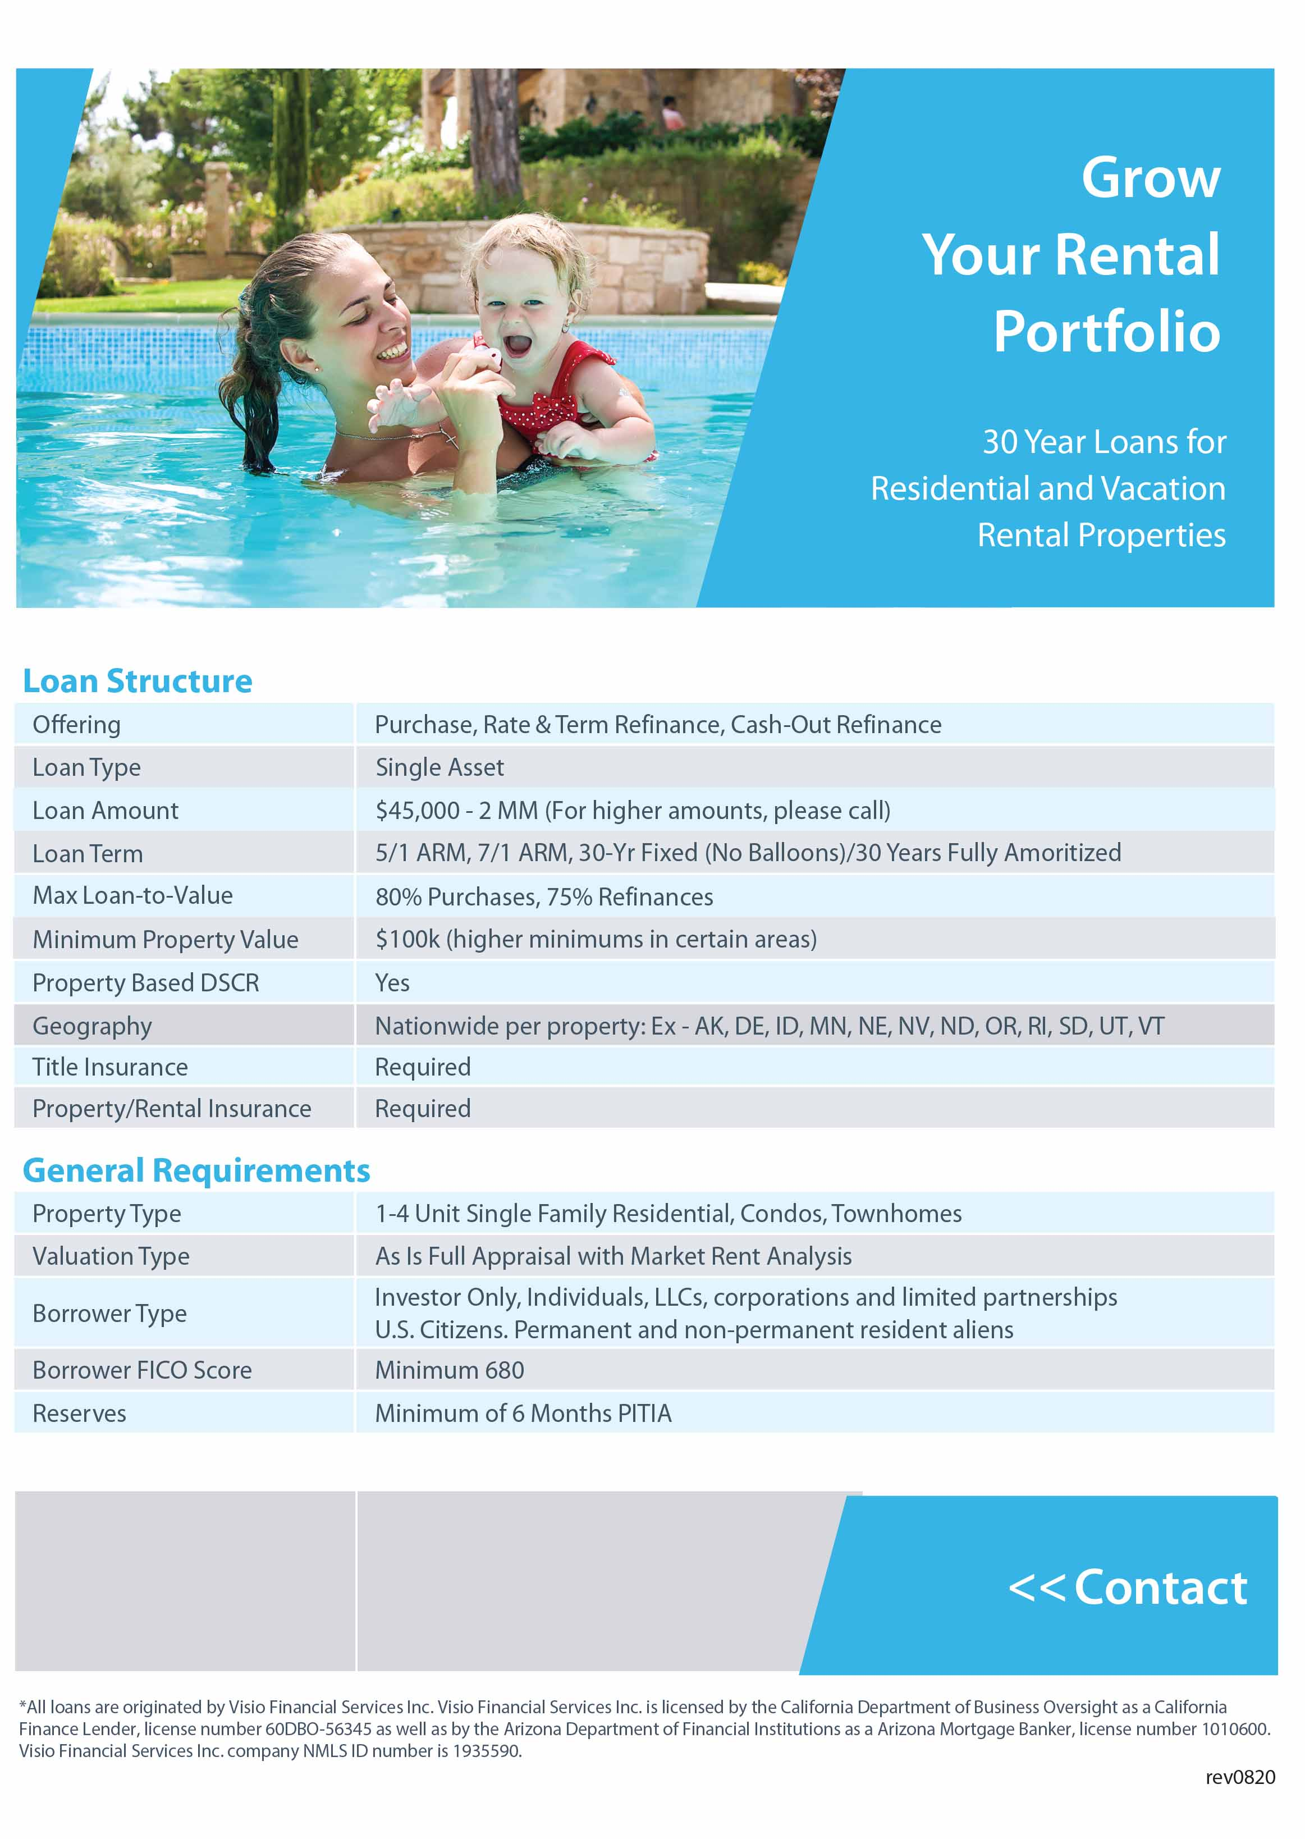

Insert additional info

Insert Contact information