Care Credit Processing

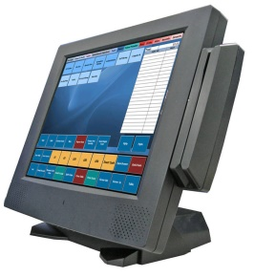 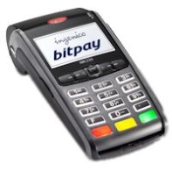

Processing through Finical and Pivotal Save from 10% to 50% Wholesale Rates

I Care Processing

I Care offers all patients WITHOUT a credit check treatments same day. All that is needed is a DL and Debit Card. I Care is a less expensive option to both the patient and doctor . I Care will also cover Care Credit Turndowns

Pivotal Processing is the largest Credit Card Processing company in North America. Payments are processed next day with a choice of tiered pricing of 1.49% plus .05 per transaction. Mid-tier bump is only .50% (company and high reward cards). For large volume accounts, cost plus pricing is available and may reduce your fees even further.

Care Credit offers additional credit to cover treatments not covered by insurance. Expensive option to both patient and doctor

Stop paying high working capital rates. If you have good credit (640 and above), you qualify for a Preferred Rate unsecured loan with approval in 48 hours or less. This is only available for professionals with 2 or more years in practice. SBA and other loans available as well.

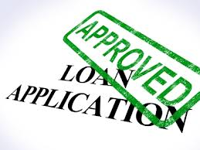

I Care currently have more than 5,000 dental practices across the USA. These practices have seen revenue increases ranging from $80,000 to $350,000.

Care Credit is also an expensive option for processing credit cards. These total fees run 2.75% to 5.75%. Care Credit requires processing through their own system. This is why two processing systems should be installed at your office to save costs.